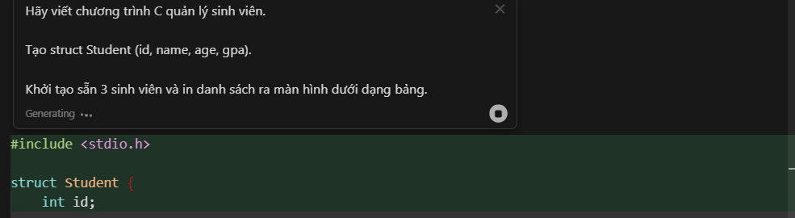

Code trả về:
#include <stdio.h>

struct Student {
int id;
char name[50];
int age;
float gpa;
};

int main() {
struct Student students[3] = {
{1, "Nguyen Van A", 20, 3.5},
{2, "Tran Thi B", 21, 3.7},
{3, "Le Van C", 19, 3.2}
};

printf("%-5s %-20s %-5s %-5s\n", "ID", "Name", "Age", "GPA");
printf("---------------------------------------------\n");
for (int i = 0; i < 3; i++) {
printf("%-5d %-20s %-5d %-5.2f\n", students[i].id, students[i].name, students[i].age, students[i].gpa);
}
return 0;
}

Kết quả:
